- The destination sap_process_automation_service.
- Information about the backing service – this is responsible to read Work items for build process automation service.
Link https://help.sap.com/docs/build-process-automation/sap-build-process-automation/configure-sap-build-process-automation-destinations

Go to BTP cockpit Connectivity destinations

URL
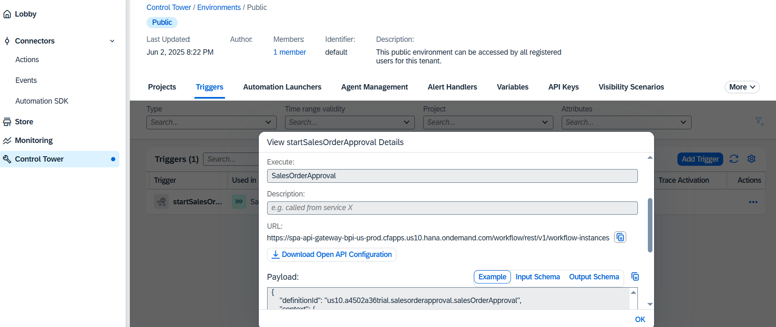

Other data you will get through your BPA service key(standard) client id client secret token authentication URL.
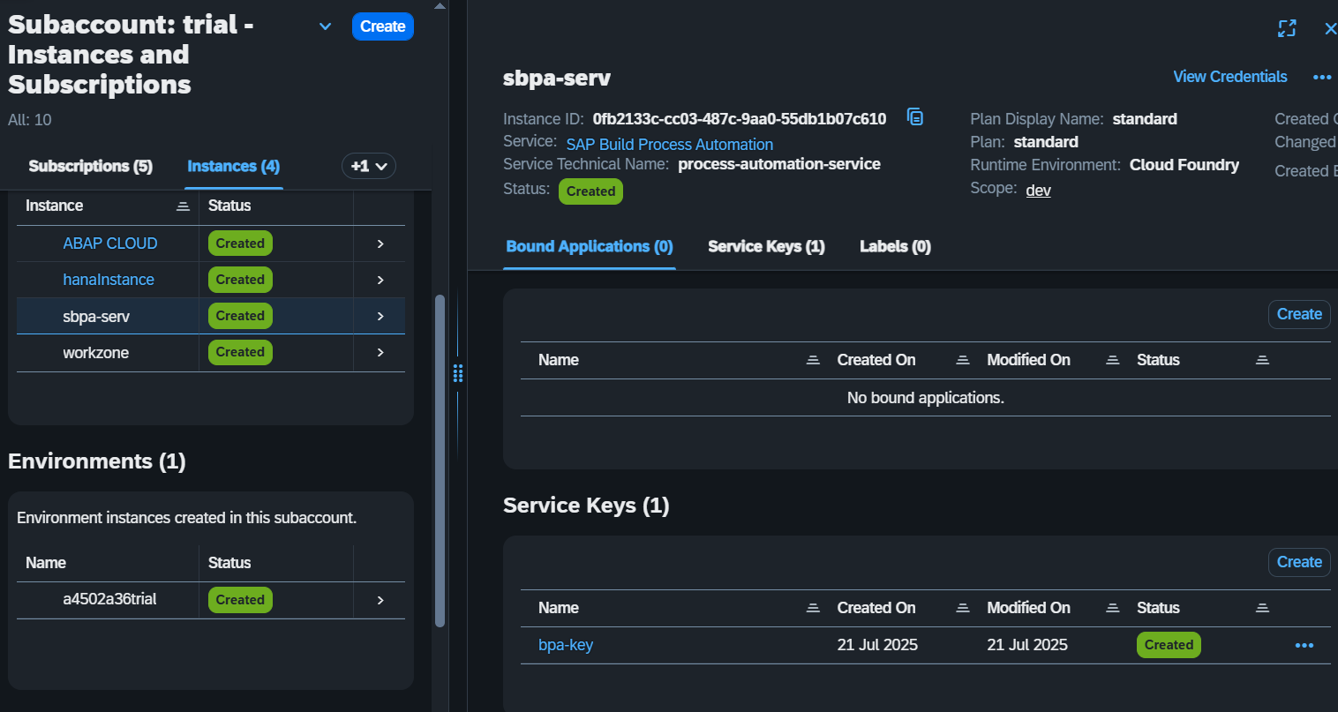

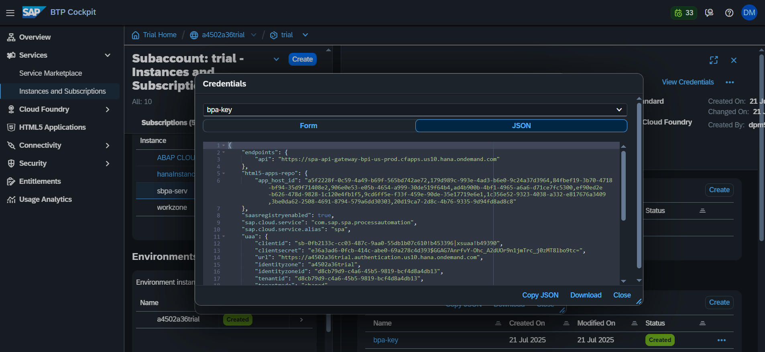

Add the destination service and check the connection.
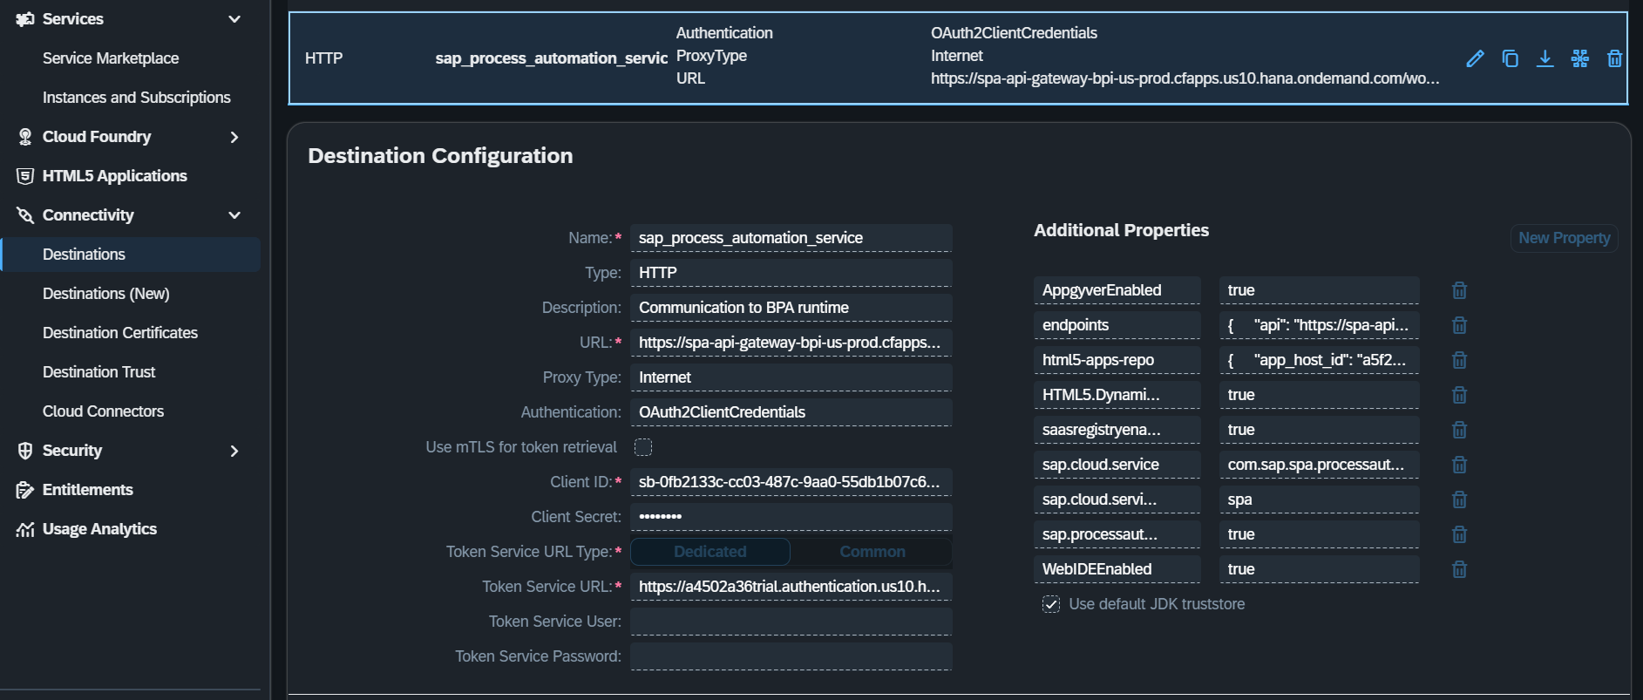
Check connection
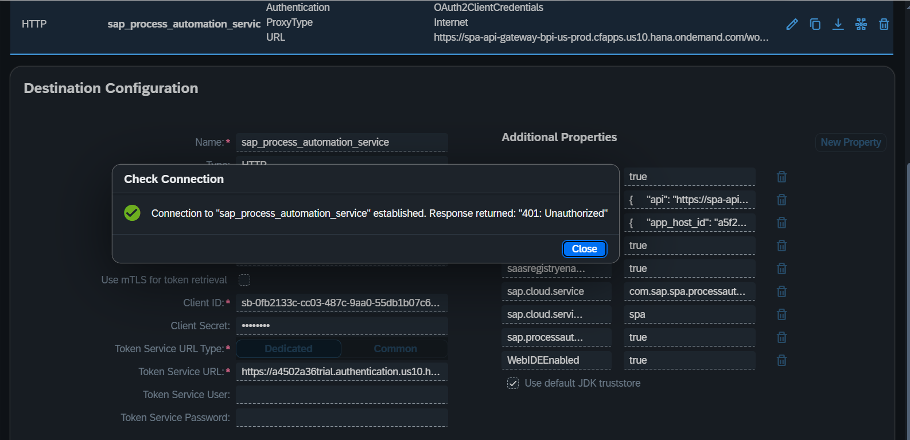
Completed.

